Exp.No:35
35. Morphological operations based on OpenCV using Black hat technique.

Aim:
To perform the Black Hat morphological operation using OpenCV.
Procedure:
- Read the input image.
- Create a structuring element.
- Apply the Black Hat operation.
- Display the original and Black Hat images.
- Save the output.
Program:
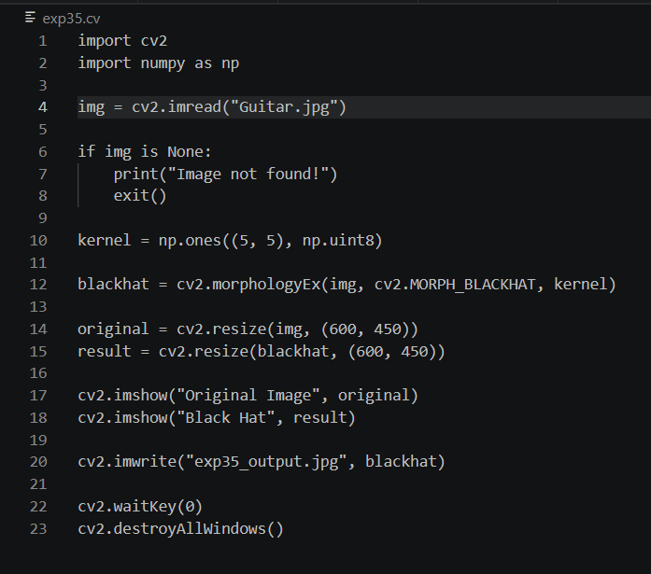

Input:


Output:
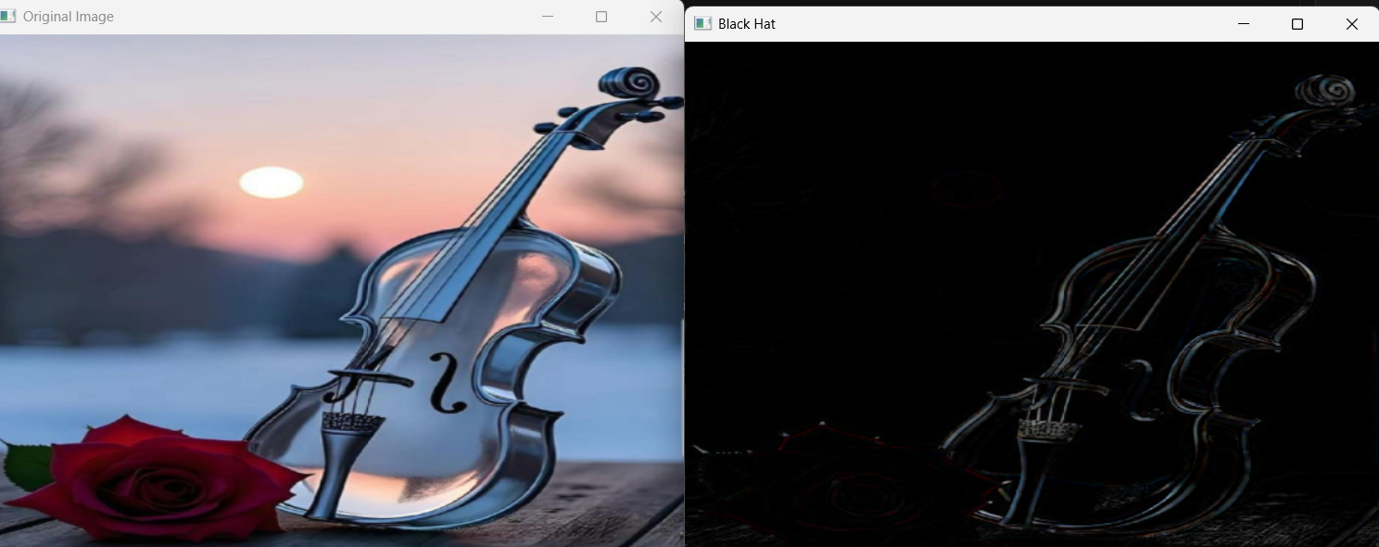

Result:
The Black Hat morphological operation was successfully performed.

